UI Automation Test

**Orikan**

Website: [www.orikan.com](http://www.orikan.com/)

Copyright © 2023, Orikan Group Pty Ltd and its subsidiaries (**Orikan**).

This publication is protected by copyright, remains the property of Orikan and is provided for specified use only (e.g. for specific product licence).

No part of this publication may be reproduced, distributed, transmitted, or stored, electronically or mechanically, for any purpose, on any media, in any form or by any means whatsoever, without Orikan’s prior written authority. Information in this publication and the products and procedures described herein are subject to change without notice.

The publication and information in the publication must be distributed to authorised persons only and held in confidence by them. The information contained herein shall be used only for the express purpose advised by Orikan (or as described within the product licence).

Orikan assumes no responsibility or liability for damages arising from the inability to use this publication or for any omissions from and errors in this publication.

# Background

The following standard user registration web site shall be used for all tasks

**Website:** <https://orikan-ui-automation-test.azurewebsites.net/>

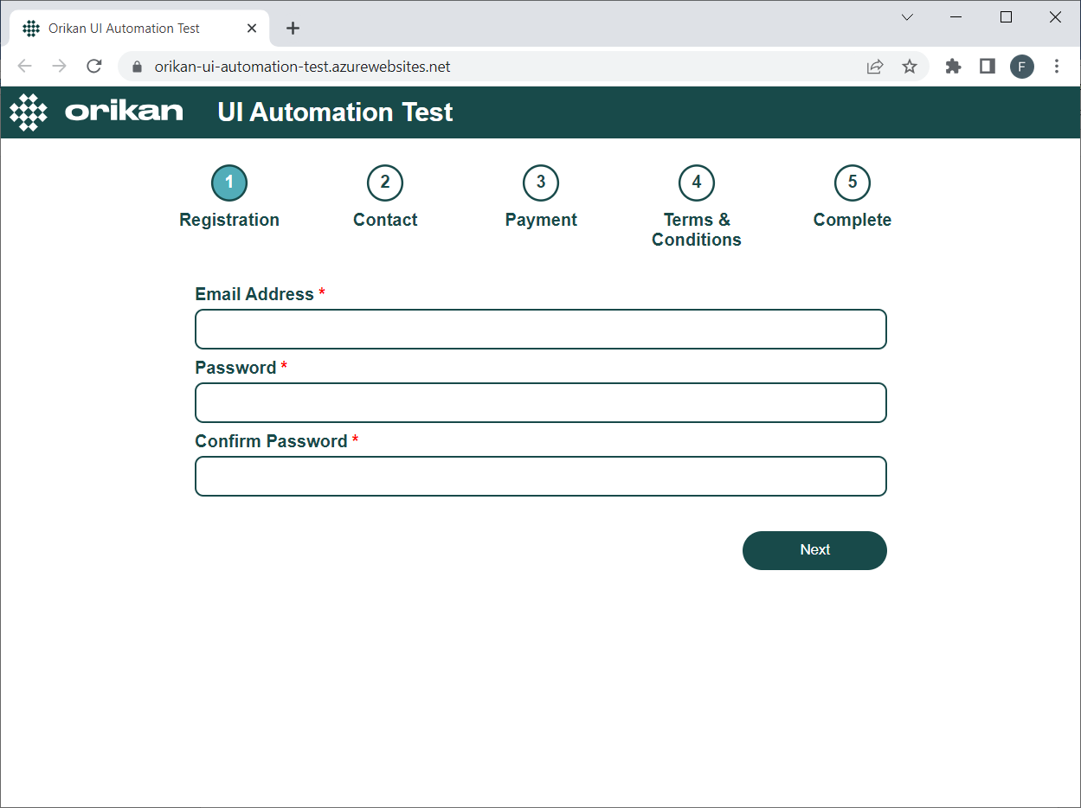

**Notes:**

* No data will be persisted from this test website and all test data remains only within the browser and is never sent to Orikan
* The following test users already exist in the system:
  + adam@orikan.com
  + betty@orikan.com
  + carl@orikan.com

# Tasks

## Task 1 – Exploratory Tests

Go to the UI Test Automation website and identify manually any issues and briefly list them including:

* **Description** – a brief description of the issue identified
* **Severity** – determine whether **High**, **Medium** or **Low** with a short explanation justifying why

|  |  |
| --- | --- |
| Description | Severity |
| After providing ‘Email Address’, ‘Password’ & ‘Confirm Password in ‘Registration’ Page, if user clicks ‘Next’ button for ‘4’ times, its skipping all next ‘4’ pages (Contact, Payment, Terms & Conditions, Complete pages) and User is successfully getting registered | Critical  User is getting registered with incomplete data |
| Inconsistency in acceptance of Email ID:   * Email Address is accepted without providing ‘.com’ * Email Address provided in capital letters is getting accepted. (Universally no email Address exists in capital letters) * Email Address not being accepted if numeric value available before ‘@’. Ex: srimanth14@gmail.com is not accepted. But srimanth14oct@gmail.com is accepted. | High  Due to unacceptance of Email Address with Numerical values, transaction is on hold |
| ‘Space’ value itself is accepted as password | High  Password should not accept space values |
| When existing Email Address provided with space in beginning or ending, its accepting for new registration with same Email Address | Medium  Chance of duplicate user creation |
| When existing email given, ‘Email address is already registered’ message is displayed. | Low  Its caption mistake in message. Instead of ‘is’, it should be ‘Was’. |
| Alerts are displaying in Contact page before providing any data | Low  Alert should be displayed if data provided is wrong. As there is issue in flow or transaction, considered as ‘Low’ |
| Special characters and alphabets are accepted in postcode | High  Postcode has to only accept numbers. |
| No alert displayed for last name and not allowing forward, if data provided and removed. | Low  Alert should be displayed if data is not provided. As there is issue in flow or transaction, considered as ‘Low’ |
| Card Number & CVV character length check not available | High  If any character gets missed or added, then value provided will be incorrect |
| Card Expiry year accepting past years | High  Expiry year can never be past. |
| In registration successful screen, beside welcome username not displayed | Medium  User name data missing in screen level. But there is no issue with transaction. |
| No defined character lengths for any fields in all pages | Low  Data consistency is missing |

## Task 2 – Automated Tests

Create an automated test suite in a testing tool of your choice (e.g. Selenium, Cucumber, Cypress, Playwright, SoapUI, etc.) that:

* automatically identifies the issues that were manually identified in Task 1
* automatically verifies currently working functionality in case it is later broken

Briefly list the test cases that you have included in your test suite.

|  |
| --- |
| Test Cases |
| Verification of each fields with Alphabets, Numericals, Alphanumericals and Special Characters |
| Verification of email address in proper format |
| Password field acceptance with Alphabets, Numericals, Alphanumericals, Special Characters and Spaces |
| Verification of all Mandatory fields by not providing data |
| Verification of Postcode field acceptance with Alphabets, Numericals, Alphanumericals, Special Characters and Spaces |
| Verification of Card Number acceptance in proper format |
| Verification of Card Expiry year in past years |

**Verification of email address in proper format:**

**public** **class** userRegistrationwithEmailCaptialLetters {

**public** **static** **void** main(String[] args) {

// **TODO** Auto-generated method stub

System.*setProperty*("webdriver.chrome.driver", "/Users/srima/Downloads/chromedriver.exe");

WebDriver driver=**new** ChromeDriver();

driver.get("https://orikan-ui-automation-test.azurewebsites.net/");

driver.findElement(By.*xpath*("//input[@id='emailAddress']")).sendKeys("SRIMANTH@G");

WebElement passwordField = driver.findElement(By.*xpath*("//input[@id='password']"));

passwordField.sendKeys(Keys.***TAB***);

//Email Id provided in the capital letters is not accepted and the test case is passed

driver.close();

}

**Verification of all Mandatory fields by not providing data:**

**public** **class** LaunchOrikanUIAutomation {

**public** **static** **void** main(String[] args) {

// **TODO** Auto-generated method stub

System.*setProperty*("webdriver.chrome.driver", "/Users/srima/Downloads/chromedriver.exe");

WebDriver driver=**new** ChromeDriver();

driver.get("https://orikan-ui-automation-test.azurewebsites.net/");

driver.findElement(By.*xpath*("//input[@id='emailAddress']")).sendKeys("SRIMANTH@G");

driver.findElement(By.*xpath*("//input[@id='password']")).sendKeys("1");

driver.findElement(By.*xpath*("//*[@id='confirmPassword']")).sendKeys("1");

driver.findElement(By.*xpath*("//button[contains(text(),'Next')]")).click();

//clicking the next button several times

driver.findElement(By.*xpath*("//button[contains(text(),'Next')]")).click();

driver.findElement(By.*xpath*("//button[contains(text(),'Next')]")).click();

driver.findElement(By.*xpath*("//button[contains(text(),'Next')]")).click();

driver.findElement(By.*xpath*("//button[contains(text(),'Next')]")).click();

driver.findElement(By.*xpath*("//button[contains(text(),'Next')]")).click(); //User Registered successfully

driver.close();

}

}

**Verification of Card Expiry year in past years:**

**public** **class** expiryDateAcceptedPreviousYears {

**public** **static** **void** main(String[] args) {

// **TODO** Auto-generated method stub

System.*setProperty*("webdriver.chrome.driver", "/Users/srima/Downloads/chromedriver.exe");

WebDriver driver=**new** ChromeDriver();

driver.get("https://orikan-ui-automation-test.azurewebsites.net/");

driver.findElement(By.*xpath*("//input[@id='emailAddress']")).sendKeys("SRIMANTH@G");

driver.findElement(By.*xpath*("//input[@id='password']")).sendKeys("1");

driver.findElement(By.*xpath*("//*[@id='confirmPassword']")).sendKeys("1");

driver.findElement(By.*xpath*("//button[contains(text(),'Next')]")).click();

//clicking the next button two times

driver.findElement(By.*xpath*("//button[contains(text(),'Next')]")).click();

driver.findElement(By.*xpath*("//button[contains(text(),'Next')]")).click();

//navigated to payment page

//Enter the past year in expiry date filed

driver.findElement(By.*xpath*("//*[@id='cardExpiryYear']")).sendKeys("2022");

driver.findElement(By.*xpath*("//*[@id='cardExpiryYear']")).sendKeys(Keys.***ENTER***);

}

}

## Task 3 – Developer Feedback

What feedback, if any, would you provide to the developers that would assist you in automating your test suite?

|  |
| --- |
| Developer Feedback |
| Password policy not available |
| Drop down for city field in Contact page |
| Card Expiry year drop down in payment page |
| Card Number inline to Card Type check required |
| Terms and Conditions preferably in English or language conversion |
| In registration successful screen, no option to redirect or navigate. Only option is to click on Logo to re-direct |

## Task 4 – Share via Email

|  |  |
| --- | --- |
| Details | Value |
| Chosen Testing Tool | Selenium |